FREE FIRE SALES DASHBOARD USING POWER BI

Introduction
In today’s digital era, the online gaming industry has emerged as one of the fastest-growing sectors in the global economy. Games like Free Fire generate massive revenue through in-game purchases such as characters, skins, elite passes, diamonds, and weapons. With millions of players across different countries, tracking and analyzing sales performance manually becomes extremely complex.

The Free Fire Sales Dashboard project is designed to address this challenge by leveraging Business Intelligence (BI) tools. Using Power BI, this project transforms raw sales data into meaningful, interactive, and visually engaging insights. The dashboard helps stakeholders understand overall sales performance, profitability, regional contributions, product-wise revenue, and achievement of sales targets.

This project demonstrates how data analytics can be applied effectively in the gaming industry to support strategic decision-making, improve revenue planning, and enhance performance monitoring.

DASHBOARD LANDING PAGE
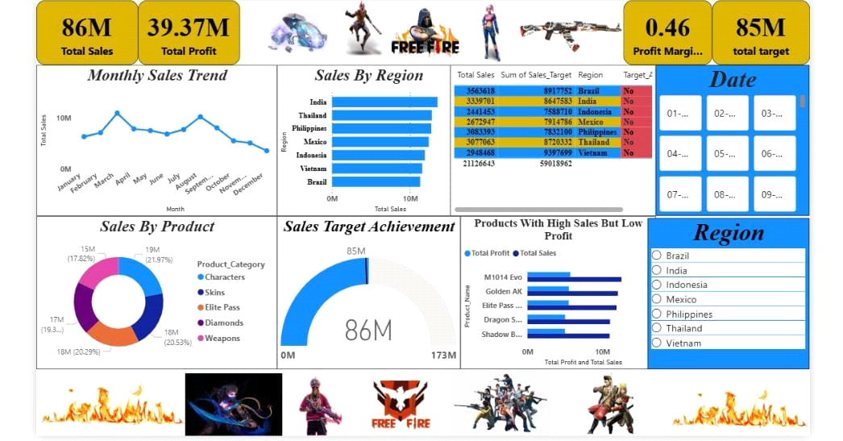

Problem Statement

Free Fire generates a large volume of sales data across multiple regions and products. However, without a centralized analytical system:
- Sales performance is difficult to track

- Regional contribution is unclear

- Product profitability is not easily measurable

- Sales targets cannot be monitored effectively

- Manual analysis leads to errors and delays

The problem addressed by this project is to design an interactive Power BI dashboard that consolidates all sales data and provides actionable insights for decision-makers.

Existing System

Before implementing Power BI, the existing system relied mainly on spreadsheets and manual analysis.

Limitations of the Existing System:
- Data stored in multiple Excel files

- Manual calculations for sales and profit

- No interactive reports or dashboards

- Time-consuming analysis process

- High chances of human error

- Limited visualization capabilities

This system was inefficient for large-scale business analysis and strategic planning.

Proposed System

The proposed system introduces an automated and interactive sales analysis solution using Power BI.

Advantages of the Proposed System:
- Centralized data analysis
- Automated calculations using DAX
- Interactive dashboards and slicers
- Real-time insights
- Improved accuracy and efficiency
- Better visualization of trends and performance

Technology Used

Microsoft Excel
Excel is used as the initial data source for storing Free Fire sales data.

Uses of Excel:
- Data collection

- Initial data inspection

- Handling missing values

- Basic formatting

- Data validation

ETL Process (Extract, Transform, Load)

ETL is a crucial process in data analytics.

- Extract: Sales data extracted from Excel files

- Transform: Data cleaned, structured, and enriched

- Load: Final transformed data loaded into Power BI

Power BI
Power BI is the core tool used in this project.

Uses of Power BI:
- Data modelling

- DAX calculations

- Interactive visualizations

- KPI tracking

- Dashboard creation

Data Collection

The dataset includes:
- Date of sales

- Region (India, Thailand, Brazil, etc.)

- Product categories

- Sales amount

- Profit amount

- Sales targets

This structured dataset enables comprehensive analysis.

Data Transformation Steps

Data transformation was performed using Power Query in Power BI.

Steps Involved:
- Removal of duplicate recorde

- Renaming columns for clarity

- Changing data types (date, currency, numeric)

- Cleaning text values

- Standardizing region and product names

- Creating calculated columns for profit and margin

- Filtering irrelevant records

These steps ensure data accuracy, consistency, and reliability.

Data Modeling

Data modeling forms the backbone of the dashboard.
Model Structure:
- Sales table as the fact table

- Date, Region, and Product tables as dimension tables

- One-to-many relationships

- Proper cardinality and filter direction

The model follows a star schema, ensuring efficient querying and performance.

Key Aspects of the Data Model

- Centralized fact table

- Separate dimension tables

- Reduced redundancy

- Accurate aggregation

- Improved performance

- Effective filtering and slicing

DAX Measures Used

Some important DAX measures include:
- Total Sales

- Total Profit

- Profit Margin

- Target Achievement

- Monthly Sales
DAX enables dynamic and accurate calculations.

KPI Summary

The dashboard highlights the following KPIs:
- Total Sales: 86 Million

- Total Profit: 39.37 Million

- Profit Margin: 0.46%

- Total Target: 85 Million

These KPIs provide a snapshot of overall business performance.

Monthly Sales Trend Analysis

The monthly sales trend helps identify peak and low sales periods.
- High sales observed during festive seasons

- Sales fluctuations across months

- Useful for forecasting and planning

Sales by Region Analysis

The regional analysis compares sales across countries.

- India and Thailand show high contribution

- Emerging markets identified

- Helps in regional strategy planning

Sales by Product Analysis

Product-wise analysis shows revenue contribution.

- Characters and Skins generate high revenue

- Elite Pass provides consistent income

- Diamonds drive in-game purchases

Sales Target Achievement

The gauge chart compares actual sales with target sales.
- Target: 85M

- Actual Sales: 86M

- Indicates successful achievement

High Sales but Low Profit Products

This analysis identifies products that require optimization.
- High sales volume

- Low profit margin

- Indicates pricing or cost issues

Charts Used

This section explains the different charts used in the Free Fire Sales Dashboard and the reason for selecting each visualization, similar to an academic project report format.

1) Monthly Sales Trend (Line Chart)
This chart displays the month-wise sales performance of Free Fire over a selected time period. It helps in identifying sales growth, decline, and seasonal patterns.

Why this chart: A line chart is best suited for time-series data as it clearly shows trends, fluctuations, and patterns over time. It allows easy comparison of sales performance across different months.
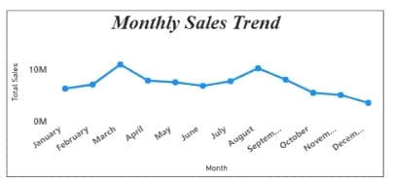

2) Sales by Region (Bar Chart)
This chart represents total sales generated from different regions such as India, Thailand, Brazil, Indonesia, Mexico, Philippines, and Vietnam. It highlights the contribution of each region to overall sales.

Why this chart: A bar chart allows easy comparison between multiple categories. It is ideal for identifying high-performing and low-performing regions quickly.
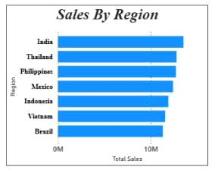

3) Sales by Product Category (Donut Chart)
This chart shows the percentage contribution of various product categories including Characters, Skins, Elite Pass, Diamonds, and Weapons to total sales.

Why this chart: A donut chart effectively represents part-to-whole relationships. It helps users understand which product categories contribute the most to overall revenue.
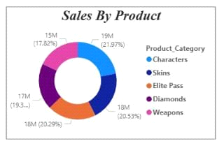
4)Sales Target Achievement (Gauge Chart)
This chart compares actual total sales with the predefined sales target. It visually indicates whether the organization has met or exceeded its target.

Why this chart: A gauge chart provides an intuitive visual representation of performance against a goal. It is highly effective for KPI tracking and management-level reporting.
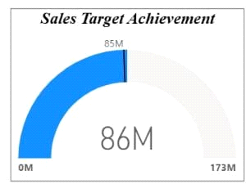

5) Products with High Sales but Low Profit (Bar Chart)
This chart identifies products that generate high sales volume but comparatively low profit. It helps in detecting areas where cost optimization or pricing strategy improvements are required.

Why this chart: A bar chart clearly compares sales and profit values across products, making it easier to identify discrepancies between revenue and profitability.
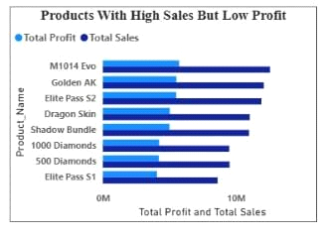

1.How is Free Fire’s overall sales performance trending over time (monthly/quarterly/yearly)?
2. Which regions contribute the highest and lowest sales revenue?
3. Which in-game items (skins, passes, weapons, diamonds) generate the maximum revenue?
4. Which product category delivers the highest profit margin?
5. How effectively is Free Fire achieving its sales targets?
6. Which regions are underperforming against their sales targets?

conclusion
the free fire sales dashboard project successfully demonstrates the use of power bi for sales analysis in the gaming industry. by converting raw data into interactive visualizations, the dashboard supports better decision-making, performance tracking, and strategic planning.this project highlights the importance of data analytics in modern business environments and serves as an effective business intelligence solution.

